**Website Review Report: Eli Lilly**

By Olivia Flynn

Submission Date: 19/02/2019

Word Count: 1020 Words

This report is a review of a publicly available website which belongs to Eli Lily and Company which operates within the same industrial sector as my own employer; McKesson, Cork.

**Table of Contents**

Introduction___________________________________________________1

Website Structure______________________________________________2

Main Features of the Website___________________________________4

Website Critique_______________________________________________5

Summary______________________________________________________7

Appendix A: Referances_________________________________________8

**Introduction**

The website which will be reviewed belongs to Eli Lilly and Company (Eli Lilly, 2019). Eli Lilly and Company focus on five core global business areas: bio-medicines, diabetes, oncology, emerging markets and animal health. (Eli Lilly, 2019) They have been in business for over one-hundred and forty years. The commitments made by its founder from the website are as follows;

He would found a company that manufactured pharmaceutical products of the highest possible quality, his company would develop only medicines that would be dispensed at the suggestion of physicians rather than by travelling salesmen and Lilly’s medicines would be based on the best science of the day. (Eli Lilly, 2019)

Eli Lilly and Company are a global corporation and their product focus is for patients worldwide.

**Website Structure**

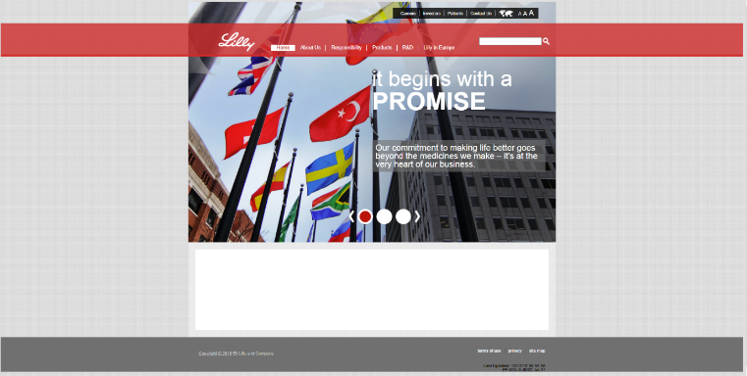When a user visits the Eli Lilly website via its URL: (<https://www.lilly.ie/>), they first arrive on a homepage with many links to other pages of the website. There is large main navigation bar in red across the centre of the page and one smaller navigation bar to the top right hand corner which has a black background. The main navigation bar features the company logo and a search box. The user can visit about fourteen different pages based on the links which are visible from the home page, but this does not include the list option to change country from the map icon.

Figure 1: Eli Lilly Homepage

The homepage features a scrolling image behind the navigation with text in the form of headings and paragraphs overlaying the image.

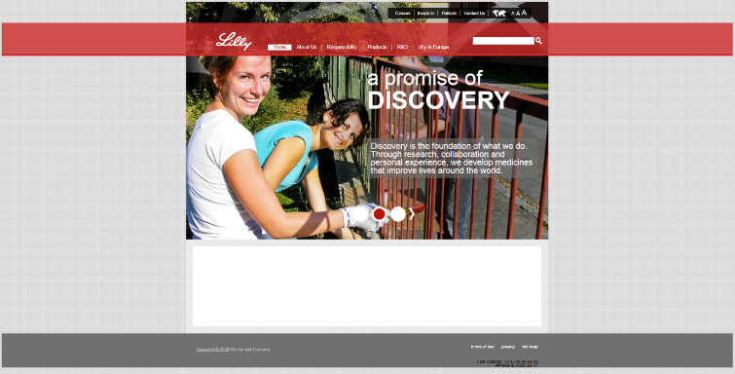

Figure 2: Second image on scrolling background image

The website features the homepage, about us page, responsibility page, products page, R&D page and Lilly in Europe page from the main navigation. This gives the impression that these are the most important areas and spreading this information is the websites purpose.

Each page tends to have written information in the form of paragraphs and bullet points and some pages include an embedded video. The website has a Contact us page but it does not include a HTML form, instead it is just static text with contact information.

**Sitemap for Eli Lilly Website**

Analysing the website with a site map tool returns a total of thirty five pages. The following graphic represents the index page in the long red box, folders in the navy boxes and various HTML pages in the multi-colour boxes.

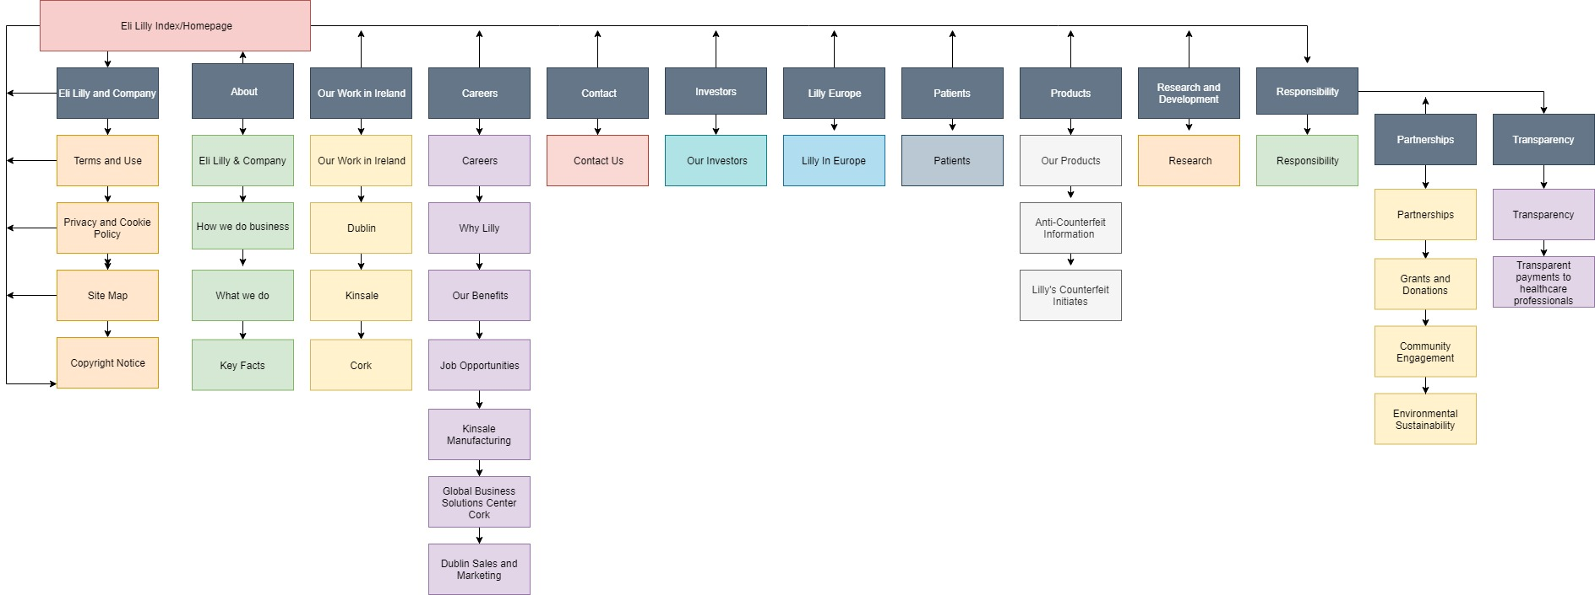

**Main Features of the Website**

The main features of Eli Lilly and Company website include information about the company, what they do and where they are located. It features the company’s brand video, which is embedded on the about page. The website features a search function allowing the user to search the entire site for a certain keyword.

The website is responsive and scales to display on mobile devices. This is something that all modern websites must do in order to ensure they are reaching their audience. A study by Statista.com showed that over half (52.2%) of all pages served in 2018 were to a mobile device (Statista, 2019).

The website features a contact page but no online form, this may be for a security reason but it doesn’t add the ease of usability by its visitors.

At the top of each page, there is a bar with different text size options. When the user clicks one it changes the size of the font in areas such as paragraphs, headings and articles to the chosen size. This carries over as the user navigates throughout the site.

**Website Critique**

There are a few areas in which the web developers of the Eli Lilly website could improve the website.

1. Empty box on homepage: When the source code is inspected, it can be seen that this was used for some kind of testing, it perhaps should not be on the home page. The code reads:



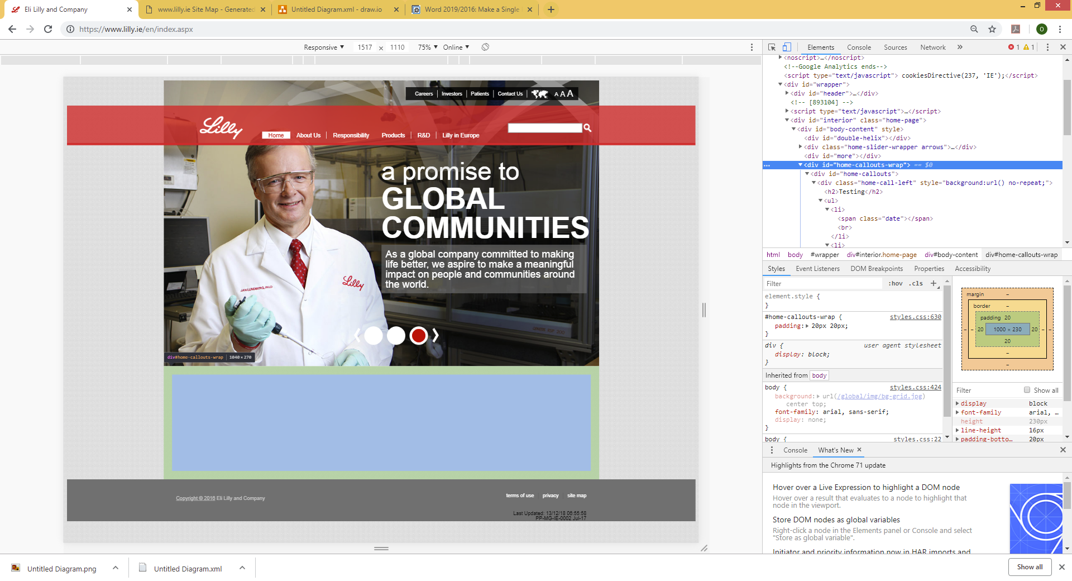

Figure 3- Empty box on homepage

1. 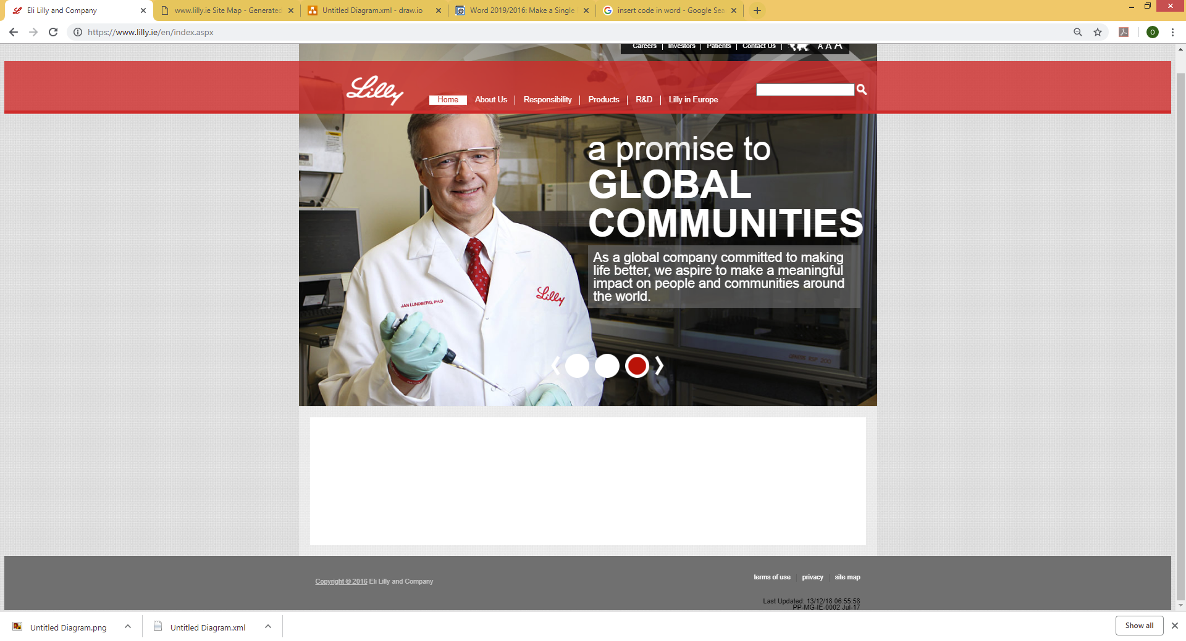Website copyright notice out of date: At the bottom of each of the sites pages, the copyright date is noted as 2016. As of writing it is 2019. To the far right of the footer there is some text which notes that last updating of the website to be in December 2018. This shows poor attention to detail and it is unclear why the copyright notice does not update when the websites content does. This should be a JavaScript which updates the date based on the users current system.

Figure 4- Outdated copyright information

1. Main navigation bar hover effects: The main navigation bar for the website features a hover over effect which is not very aesthetically pleasing. When a link is hovered over, the navigation bar extends out into a large red rectangle which overlaps the homepage banner with the company logo. This gives the website a feel as though it was designed by an amateur and not someone who understands good user interface design.



Figure - Main Navigation Bar hover effect

1. The website has been designed using a boxed layout. This is opposed to a full-width layout where the content spans the entire width of the page. The box layout gives the website a sense of uniformity and structure. A full-width layout tends to be used for a minimalist website with small text contents. In this case the boxed layout does suit the needs of the website.
2. No HTML contact form: This oversight makes in more inconvenient for people to contact the company. If they had a form it would be more user friendly, however the page does cite not using the website to contact concerning adverse effects after using medication produced by the company and to contact a doctor or healthcare professional instead. (Eli Lilly and Company, 2019) So perhaps not including a contact form is an intentional step by the company.

**Summary**

To summarise, the EIi Lilly website is very straightforward to use but it is lacking a certain amount of quality which would be expected from a large company’s website. It has some very good features such as user accessibility controls and website search function. This ensures that visitors can easily and quickly find the specific information they may be looking for. Some of the design elements of the site however, give it a dated feel and in some areas (like the outdated copyright in the footer), give the sense the website has not been updated and maintained for some time.

**Appendix A: References**

Eli Lilly, 2019. *About.* [Online]   
Available at: https://www.lilly.ie/en/about/index.aspx  
[Accessed 21 January 2019].

Eli Lilly, 2019. *Eli Lilly and Company.* [Online]   
Available at: https://www.lilly.ie/en/index.aspx  
[Accessed 21 January 2019].

Eli Lilly, 2019. *What We Do.* [Online]   
Available at: https://www.lilly.ie/en/about/what-we-do.aspx  
[Accessed 21 January 2019].

Statista, 2019. *Percentage of all global web pages served to mobile phones from 2009 to 2018.* [Online]   
Available at: 2019, S. (2019). Mobile share of website visits worldwide 2018 | Statistic. [online] Statista. Available at: https://www.statista.com/statistics/241462/global-mobile-phone-website-traffic-share/ [Accessed 29 Jan. 2019].  
[Accessed 29 January 2019].

Word Count: 1020 Words